PERSONNEL
- HAVE FUN!
  - Don’t stress out.
  - Laugh at your mistakes.
  - Laugh louder at others’ mistakes .
- If you screw up, admit it. Take the ribbing and move on. Someone else’s turn is coming! .
- Don’t lay real-world items on the layout (food, drinks, throttles, etc.) except in clear, unscenicked areas. Particularly avoid putting anything on the tracks!

GENERAL
- Speed Limits:
  - Mainline
    - As posted, or
    - Passenger Trains – 80 mph.
    - Freight Trains – 55 mph.
  - Mainline sidings
    - As posted, or
    - All trains – 45 mph.
  - Branchlines
    - As posted, or
    - All trains – 45 mph.
  - Passenger Yards
    - As posted, or
    - All Trains – 10 mph.
  - Freight Yards
    - As posted, or
    - All trains – 10 mph.
  - Other trackage
    - As posted, or
    - All trains – 20 mph.

TRAIN PRIORITIES
- Eastbound trains have priority over westbound trains.
- First Class trains have priority over lower class trains.
- Extra trains have precedence over other trains at the Dispatcher’s discretion.
- The Dispatcher may overrule any priority rule for a specific train (for example, may assign a westbound train priority over all eastbound trains).
  - The Dispatcher may not overrule priority rules for all trains (for example, may not assign all westbound trains – as a group – priority over all eastbound trains).

TRAIN OPERATION
- If the lead locomotive has a headlight, it will be on at all times after leaving the engine facility until arriving at its destination and entering that engine facility.
  - If equipped, the headlight will be dimmed when:
    - Stopped in a siding.
    - Working in the yard when another operating locomotive is present.
  - If not equipped with a headlight, ADD ONE!
- If the locomotive is sound equipped, the bell will be rung when
  - Moving in or through a yard. Exception: Yard switcher engineers may silence the bell at their discretion.
  - Approaching a grade crossing.
- If the locomotive is sound equipped, the whistle will sound when
  - Approaching a station:

  - Approaching a grade crossing:

  - Prior to beginning to move:
(Forward)
(Backward)
Note: Locomotives working the yard may dispense with 11.c.
- If the locomotive is not sound equipped, the engineer shall make “ding ding” and “whoo whoo” noises in accordance with the above rules for sound-equipped locomotives.

TRAIN MOVEMENT
- DO NOT enter the mainline without dispatcher approval. Use the telephone system when available to obtain dispatcher direction.
  - Remaining in a siding (do not throw the turnouts) until specific instruction / approval of the dispatcher has been obtained.
  - Remain within yard limits where present.
  - Remain in the switching area or on other secondary track.
- Do not enter a manned yard (one which has a yardmaster) without the yardmaster’s permission.
  - Remain outside yard limits.
  - When permission to enter is granted, follow the yardmaster’s directions.
- When arriving at an unmanned yard / switch area, a train already in the area has priority unless otherwise directed by the dispatcher.
  - Absent dispatcher direction, you can set up any working arrangement you like with an already-present train crew.
  - If no other train is present, work however you want within these rules.
South Carolina Canal & Rail Road Company
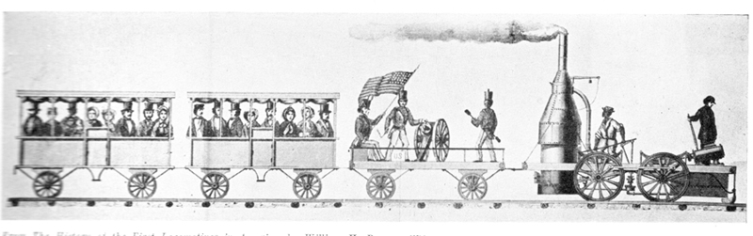HO Layout
of the
Charleston Area Model Railroad Club

Rules for Operations
Version 1.1
30 March 2012
Copyright 2012 CAMRC

